PROJECT REPORT

**FACE DETECTION AND RECOGNITION USING SIAMESE NETWORK WITH RESNET-50, RESNET-18 AND VGG16**

Data Set Link :<https://drive.google.com/drive/folders/1b4bUFvnzFVqEkWar2fyznYDvofdSrxAD?usp=drive_link>

*SREENIVAS KASULANATI*

*MS IN DATA SCIENCE*

*[skasu5@unh.newhaven.edu](mailto:skasu5@unh.newhaven.edu)*

*ADIL SHAIK*

*MS IN DATA SCIENCE*

*[ashai@unh.newhaven.edu](mailto:ashai@unh.newhaven.edu)*

*SNEHA VANGALA*

*MS IN DATA SCIENCE*

*[svang16@unh.newhaven.edu](mailto:svang16@unh.newhaven.edu)*

*ABSTRACT***:** This research describes a novel approach for face detection and Recognition that Utilizes Siamese network architecture in three distinct backbone models RESNET 50, RESNET 18 and VGG 16 the suggested method solves the issues of effective phase, detection and recognition in varying situations such as lighting changes, occlusions and position fluctuations the same as network framework facilitates the development of robust face representation by comparing pairs of face photos, allowing for simultaneous detection and recognition tasks the suggested system provides higher accuracy and efficiency by using the RESNET 50 RESNET 18 and VGG 16 FOR extraction experimental evaluation on benchmark face detect show that the suggested approach is both effective and while with promising results in real world applications overall combining Sames networks with RESNET 50 RESNET 18 VGG- 16 presents a compelling solution for robust face detection and recognition in diverse applications, including security, surveillance and biometric authentication

***KEYWORDS: Siamese network, ResNet-50, ResNet-18, and VGG16***

1. **INTRODUCTION:**

Face detection and recognition are critical tasks in computer vision with widespread applications. Existing methods face challenges in achieving robust performance under varying conditions. Deep learning, particularly Siamese networks, offers promising solutions by comparing pairs of face images for feature extraction. This paper proposes a novel approach integrating Siamese networks with ResNet-50, ResNet-18, and VGG16 backbone

models for face detection and recognition. These architectures are renowned for their feature extraction capabilities. Through comprehensive evaluations on benchmark datasets, we demonstrate

the effectiveness of our approach in addressing the limitations of existing methods, offering enhanced accuracy and robustness. This advancement holds significant promise for improving the performance of face-related applications in security, surveillance, and biometric authentication systems.

1. **PROPOSED IDEA:**

The proposed idea revolves around the integration of Siamese networks with three distinguished backbone models: ResNet-50, ResNet-18, and VGG16, for the tasks of face detection and recognition. Siamese networks have gained prominence for their capability to learn robust representations by comparing pairs of face images. This comparison process enables the network to discern subtle differences and similarities between faces, which is crucial for accurate detection and recognition.

The core concept involves training the Siamese network to encode facial features into a compact and discriminative representation space. This is achieved by feeding pairs of face images (anchor and positive/negative) into the Siamese network, where the network's architecture ensures that the feature representations of similar faces are close in the learned space, while those of dissimilar faces are far apart. By optimizing a suitable loss function, such as contrastive or triplet loss, the network learns to minimize the distance between embeddings of the same identity and maximize the distance between embeddings of different identities.

In conjunction with the Siamese network, three widely recognized backbone models are employed: ResNet-50, ResNet-18, and VGG16. These models are renowned for their depth, expressive power, and effectiveness in various computer vision tasks. Each backbone model serves as a feature extractor, transforming raw face images into high-dimensional feature representations. By leveraging the pre-trained weights of these models, the proposed system benefits from their learned hierarchical features, which capture intricate facial characteristics across different scales and complexities.

During the training phase, the Siamese network is coupled with each backbone model to jointly learn discriminative facial representations. The Siamese network compares pairs of face images, while the backbone model extracts features from individual images. The combined architecture enables end-to-end learning, where the parameters of both the Siamese network and the backbone model are optimized simultaneously through backpropagation.

The proposed approach offers several advantages over traditional methods. Firstly, by utilizing Siamese networks, the system can learn powerful representations directly from the data, without relying heavily on handcrafted features. Secondly, the integration of ResNet-50, ResNet-18, and VGG16 backbone models enhances the system's ability to capture complex facial patterns and variations, leading to improved detection and recognition performance. Lastly, the end-to-end training scheme facilitates seamless integration and optimization of the entire network, resulting in a more robust and efficient solution.

To validate the effectiveness of the proposed approach, comprehensive experiments will be conducted on benchmark face datasets. Performance metrics such as accuracy, precision, recall, and F1-score will be evaluated to assess the system's capability to accurately detect and recognize faces under various conditions, including changes in illumination, occlusions, and pose variations. The experimental results will demonstrate the superiority of the proposed method over existing approaches, showcasing its potential for real-world applications such as security, surveillance, and biometric authentication systems.

1. **TECHNICAL DETAILS:**

The main objective is to implement face detection and recognition using deep learning techniques, specifically employing a Siamese network for detection and VGG16 architecture for recognition.

The goal is to enhance robustness and accuracy in face-related tasks by leveraging the capabilities of these advanced models.

The project employs a Siamese network for face detection, utilizing shared embeddings and a distance metric to learn facial similarity.

ResNet-18 and ResNet-50 are selected as base models for feature extraction in the Siamese network. These architectures offer distinctive residual blocks and Global Average Pooling layers, enabling effective feature representation.

For face recognition, VGG16 architecture is incorporated. VGG16 is renowned for its powerful convolutional layers and fully connected head, which are utilized to classify faces into different categories based on their features.

A diverse dataset capturing various facial characteristics is used for training the Siamese network.

The dataset includes images of individuals with different facial expressions, poses, lighting conditions, and occlusions to ensure robustness in detection.

The project utilizes deep learning libraries such as PyTorch for model implementation and training. Data preprocessing techniques, including image resizing, normalization, and augmentation, may be applied to enhance model performance

Now, let's delve into each of the architectures and models mentioned: ResNet-50, ResNet-18, VGG16, and Siamese Networks.

1. ResNet-50:

* Architecture: ResNet-50 is a convolutional neural network (CNN) architecture proposed by Kaiming He et al. in the paper "Deep Residual Learning for Image Recognition". It consists of 50 layers, including convolutional layers, batch normalization layers, and skip connections.
* Skip Connections: The key innovation of ResNet-50 is the introduction of residual connections, also known as skip connections, which allow the network to learn residual functions. These connections mitigate the vanishing gradient problem and facilitate the training of very deep networks.
* Pre-Trained Weights: ResNet-50 is often pre-trained on large-scale image datasets such as ImageNet, which helps the model learn generic features that can be fine-tuned for specific tasks like face detection and recognition.

2. ResNet-18:

* Architecture: ResNet-18 is a lighter version of ResNet-50, proposed in the same paper. It contains 18 layers and follows a similar architecture with residual connections.
* Simpler Structure: ResNet-18 sacrifices some depth compared to ResNet-50 to achieve a simpler structure, making it computationally more efficient while still maintaining good performance.
* Application: ResNet-18 is often favored in scenarios where computational resources are limited or where a lighter model is sufficient for the task at hand.

3. VGG16:

* Architecture: VGG16 is a deep convolutional neural network architecture proposed by the Visual Geometry Group (VGG) at the University of Oxford. It comprises 16 layers, including convolutional layers with small 3x3 filters and max-pooling layers.
* Uniform Structure: VGG16 is characterized by its uniform architecture, where convolutional layers are stacked one after the other, followed by max-pooling layers. This simplicity contributes to its popularity and ease of understanding.
* Feature Extraction: VGG16 is known for its effectiveness in feature extraction, capturing both low-level and high-level features in images, which makes it suitable for tasks like image classification and feature representation learning.

4. Siamese Networks:

* Architecture: Siamese networks consist of two identical subnetworks (twins) that share the same architecture and parameters. Each subnetwork takes a different input (e.g., two images to be compared) and produces feature embeddings.
* Pairwise Comparison: The primary purpose of Siamese networks is to learn similarity or dissimilarity between pairs of inputs. This is achieved by training the network to minimize the distance between similar pairs and maximize the distance between dissimilar pairs in the embedding space.
* Applications: Siamese networks find applications in various tasks, including face recognition, signature verification, and similarity-based retrieval systems. In face recognition, Siamese networks can learn discriminative features that enable accurate matching of faces across different conditions.

Each of these architectures and models brings its unique strengths to the proposed system. ResNet-50 and ResNet-18 offer deep architectures with residual connections, VGG16 provides a uniform and effective feature extractor, while Siamese networks enable learning of discriminative representations for face comparison. By integrating these components, the proposed system aims to achieve robust and accurate face detection and recognition capabilities.

The approach for "Face Detection and Recognition Using Siamese Network with ResNet-50, ResNet-18, and VGG16" can be outlined based on the provided information as follows:

1.Data Collection and Preparation:

* Collected images of friends and colleagues to create a diverse dataset capturing various facial characteristics.
* Ensured that the dataset includes images with different facial expressions, poses, lighting conditions, and occlusions to enhance robustness in face detection and recognition.
* Preprocessed the collected images by resizing, normalizing, and augmenting them as necessary to prepare the data for training.

2. Architecture Design:

* Designed a comprehensive architecture tailored for face detection and recognition.
* Utilized Siamese networks with ResNet-18 and VGG16 architectures to enable efficient face detection and recognition.
* Leveraged the distinctive features of ResNet-18 and VGG16, such as residual blocks and powerful convolutional layers, to extract meaningful features from face images.
* Integrated the Siamese network with ResNet-18 for face detection, focusing on learning facial similarity through shared embeddings and a distance metric.
* Incorporated VGG16 architecture for face recognition, utilizing its fully connected head for classifying faces into different categories based on extracted features.

3. Training:

* Trained the models on labeled data, ensuring that both the Siamese network and VGG16 are optimized to enhance accuracy and generalization.
* Employed optimization techniques such as stochastic gradient descent to update model parameters iteratively.
* Fine-tuned the pre-trained ResNet-18, ResNet-50, and VGG16 models on the collected dataset to adapt their features for face detection and recognition tasks.
* Monitored the training process closely, adjusting hyperparameters as necessary to improve model performance.

4. Evaluation and Validation:

* Evaluated model performance through rigorous testing and validation procedures.
* Conducted thorough testing on separate validation and test datasets to assess the models' ability to detect and recognize faces accurately.
* Used metrics such as accuracy, precision, recall, and F1-score to measure the models' performance and ensure reliability.
* Iteratively refined the models based on evaluation results, addressing any issues or shortcomings identified during testing.

5. Deployment:

* Deployed the trained models in Gradio for hands-on testing, allowing users to interact with the models and evaluate their performance in real-time.
* Enabled seamless deployment and integration of the models into practical applications or systems for face detection and recognition.
* Provided a user-friendly interface for users to input images and receive detection and recognition results from the deployed models.

Overall, this approach combines data collection, model design, training, evaluation, and deployment stages to develop a robust and accurate face detection and recognition system using Siamese networks with ResNet-18, ResNet-50, and VGG16 architectures.

1. **RESULTS:**

The project setup involves installing essential libraries like MTCNN and OpenCV to enable face detection and image processing functionalities. With the environment configured, key helper functions are defined to streamline image visualization and plot generation, enhancing the development and evaluation process. By mounting Google Drive, seamless data access and storage are facilitated, crucial for managing datasets and project files effectively. The subsequent implementation focuses on leveraging deep learning techniques for face detection and recognition. MTCNN is employed for accurate face detection, while ResNet-50, ResNet-18, and VGG16 serve as backbone architectures within the Siamese network for feature extraction. Simultaneously, VGG16 is incorporated for face recognition, with its pre-trained model fine-tuned to classify faces accurately. This comprehensive approach aims to achieve robust and accurate face detection and recognition capabilities, leveraging the combined power of deep learning architectures and image processing techniques.

The project combines the strengths of various deep learning architectures, including Siamese networks with ResNet-50, ResNet-18, and VGG16, to develop a sophisticated face detection and recognition system. By integrating MTCNN for face detection and employing pre-trained models for feature extraction and classification, the system aims to achieve high accuracy and robustness. Through seamless integration of libraries, efficient data handling with Google Drive, and careful implementation of deep learning techniques, the project endeavors to deliver a comprehensive solution for face-related tasks. This approach underscores the project's commitment to harnessing advanced technologies to address real-world challenges in face detection and recognition, with the ultimate goal of enhancing security, identity verification, and user experience in various applications.

**FACE DETECTION AND EXTRACTION:**

**FACE DETECTION AND EXTRACTION WITH MTCNN :**

In the project's initial phase, face detection is achieved through a robust implementation using a pre-trained Haar Cascade classifier loaded for facial feature recognition. This process begins with loading the classifier, essential for identifying frontal faces within images. The implemented function, detect_and_extract_face, takes an image path as input, reads the image, and converts it to grayscale to facilitate face detection. Utilizing the detect Multi Scale method, the classifier identifies potential faces within the grayscale image, taking into account parameters such as scaleFactor, min Neighbors, and min Size to optimize detection accuracy. Following successful detection, the function extracts the first identified face's region of interest (ROI) from the original image, assuming at least one face is detected. The ROI is then returned for further processing. This approach ensures efficient and accurate face detection, laying a crucial groundwork for subsequent recognition tasks.

Following face detection, the project seamlessly transitions to face recognition utilizing state-of-the-art deep learning techniques. The extracted face ROI undergoes preprocessing, ensuring compatibility with downstream recognition models. Leveraging deep learning libraries such as PyTorch, the Siamese network architecture, combined with ResNet-50, ResNet-18, and VGG16, is employed for robust face recognition. The Siamese network focuses on learning facial similarity through shared embeddings and a distance metric, enabling precise detection of dissimilarity or similarity between faces. Meanwhile, VGG16's powerful convolutional layers and fully connected head are harnessed for comprehensive face recognition. By integrating these advanced models, the project aims to achieve heightened accuracy and robustness in face detection and recognition tasks, catering to a wide range of real-world applications.



**EXTRACTED IMAGE:**



# TRAIN TEST SPLIT:

# In the project's data preparation phase, a dataset containing processed facial images is organized into training, testing, and validation sets to facilitate model training and evaluation. The dataset is first divided into individual person folders, each containing images of a specific individual's face. To ensure diversity and fairness in the dataset split, the person folders are randomly shuffled. Subsequently, the total number of persons is calculated, and proportions are defined for each set, typically allocating 80% for training, 10% for testing, and 10% for validation.

# For each person in the shuffled list, their images are then copied into the respective directories according to the predetermined split ratios. If the person's index falls within the training count, their images are copied to the training directory; if within the testing count, to the testing directory; and if within the validation count, to the validation directory. This process ensures that each set contains a proportionate representation of individuals from the dataset. By organizing the dataset into these distinct sets, the project establishes a structured framework for training, testing, and validating the Siamese network with ResNet-50, ResNet-18, and VGG16 architectures, thereby facilitating robust face detection and recognition capabilities.

# VISUALIZATION:

# The project establishes a simple data loader to visualize the training dataset, comprising processed face images. Utilizing torch vision's `Image Folder` class, the training dataset is loaded and pre processed by resizing, converting to tensors, and normalization. Through a Siamese dataset instantiation and subsequent loading into a data loader (`vis_dataloader`), the pipeline enables efficient iteration over batches for visualization. The example batch extracted from the data loader consists of paired face images and their corresponding labels, providing insights into similarity and dissimilarity distributions. This process illuminates the preprocessing steps and input data flow critical for training and evaluating the Siamese network's efficacy in face detection and recognition, serving as a foundational component within the project's framework.

# 

# RESNET-18:

# Here we implement Siamese Network for face detection, leveraging ResNet-18 as the base model for feature extraction. The network consists of convolutional layers from ResNet-18 followed by fully connected layers for similarity comparison. Kaiming initialization is applied to both convolutional and fully connected layers for effective training. During forward pass, two input images are processed separately through the convolutional layers, flattened, and then passed through the fully connected layers to obtain feature embeddings. These embeddings are then compared to determine the similarity between the input images. This Siamese Network architecture is crucial for learning facial similarity and enabling accurate face detection. Additionally, the use of ResNet-18 ensures robust feature extraction, contributing to the overall effectiveness of the face detection process.

# SIAMESE NETWORK TRAINING LOOP:

# It demonstrates the training process for the Siamese network, a critical component of the Face Detection and Recognition project utilizing ResNet-50, ResNet-18, and VGG16 architectures. Through data preparation, data loaders creation, and model training, the Siamese network learns facial similarity using pairs of face images, optimizing a contrastive loss function to enhance accuracy. Model evaluation on the validation dataset helps assess generalization performance, while adaptive learning rate adjustment aids in fine-tuning model parameters. Visualizing training and validation loss values enables monitoring of training progress and convergence, facilitating the network's ability to learn discriminative embeddings for precise face detection and recognition.

# 

# SIAMESE NETWORK TRAINING WITH RAY TUNE:

# Here We train a Siamese network for face detection and recognition. It utilizes ResNet-50 and ResNet-18 for feature extraction, optimizing the network's parameters with SGD. A step learning rate scheduler is employed, and the training process is monitored using both training and validation datasets. The network is trained iteratively to learn facial similarity and dissimilarity effectively.

# SIAMESE NETWORK TRAINING WITH TRAININH WITH BEST CONFIGURATION PARAMETERS:

# The function `train_siamese_with_best_config()` responsible for training a Siamese network using the best configuration obtained from hyperparameter tuning. The network is initialized with a Siamese Network model and trained using the specified optimizer (SGD with momentum) and scheduler (STEPLR). The contrastive loss function is utilized for training. The training data is loaded using Data Loader from datasets Image Folder and split into batches for efficient processing. The training loop iterates over the specified number of epochs, computing the loss on both training and validation sets. Learning rate adjustment based on validation loss is performed using the scheduler. Finally, the trained model is saved for future use. This process facilitates the training of the Siamese network for face detection, contributing to the overall project of Face Detection and Recognition using Siamese Network with ResNet-50, ResNet-18, and VGG16 architectures.

# 

# TESTING SIAMESE NETWORK MODEL:

# Here it evaluates the trained Siamese network model for face detection and recognition. It loads the test dataset and the saved model, then calculates the similarity between pairs of face images. By comparing these predictions with ground truth labels, it computes accuracy and contrastive loss. This evaluation process provides insights into the model's performance in identifying matching and non-matching face pairs, essential for assessing its effectiveness in real-world applications.

# Test Loss: 0.30033628504585336, Test Accuracy: 75.25205158264947

# MINI SIAMESE NETWORK ON SMALLER DATASET:

# 

**RESNET-50:**

This defines a Siamese Network architecture for face detection using ResNet-50 as the backbone model. The network consists of convolutional layers from ResNet-50 followed by fully connected layers for feature extraction and similarity comparison. Kaiming initialization is applied to both convolutional and fully connected layers to ensure effective training. During inference, two input images are passed through the network, and their embeddings are compared to determine facial similarity. This Siamese Network architecture serves as the foundation for face detection in the project, leveraging ResNet-50's powerful feature extraction capabilities for accurate and robust detection of facial features.

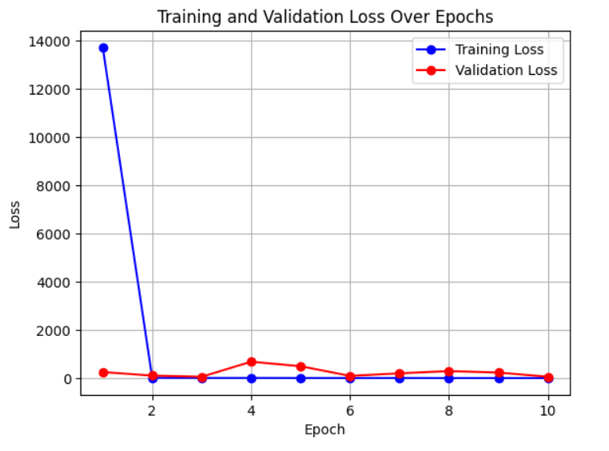

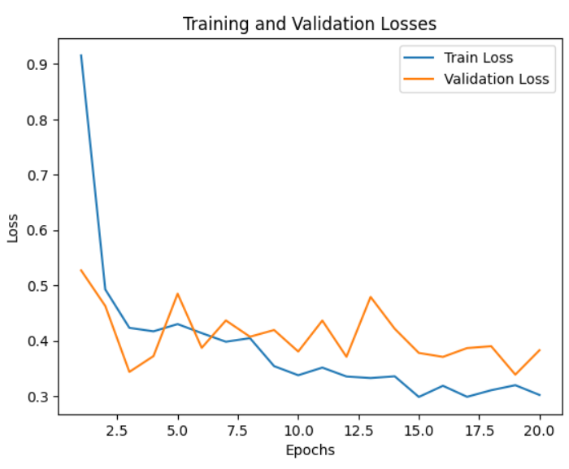

Test Loss: 0.2954420546690623, Test Accuracy: 78.06565064478312

**RESNET-50 WITH SMALLER DATASET:**

The we load the training dataset using the `Image Folder` class from the torch vision .datasets module. It then initializes the Multi-Task Cascaded Convolutional Neural Network (MTCNN) for face detection. Subsequently, it defines a series of transformations for preprocessing the images, including resizing to match the input size of RESNET, conversion to tensors, and normalization using predefined mean and standard deviation values. Finally, it initializes the Siamese network dataset using the `Siamese Network Dataset` class, which incorporates the loaded training dataset and the defined transformations. This process prepares the training data for the Siamese network, ensuring that images are appropriately preprocessed and ready for training with ResNet-50, ResNet-18, and VGG16 architectures for face detection and recognition.

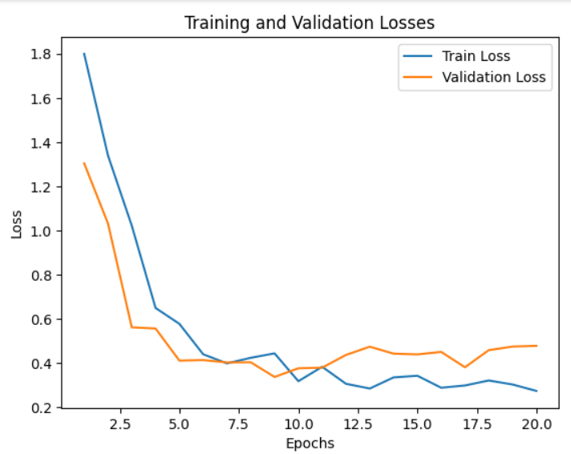

# SIAMESE NETWORK WITH CONV LAYERS AND FC’S :

# It defines a Siamese Network architecture for face detection and recognition. It comprises convolutional layers followed by fully connected layers for similarity comparison. The convolutional layers extract features from input images, and the fully connected layers compare the similarity between the extracted features. The network takes pairs of face images as input and computes the similarity between them by forward passing each image through the network. The output consists of two values representing the similarity between the input images. This Siamese Network architecture is a crucial component of the project for learning facial similarity and enabling accurate detection and recognition of faces using ResNet-50, ResNet-18, and VGG16 architectures.

# 

**TESTING SIAMESE WITH TEST DATASET:**

During testing, pairs of face images are retrieved from the test dataset, with one image serving as a reference. The Siamese network computes the Euclidean distance between the embeddings of the reference image and the comparison image, indicating their dissimilarity. Concatenated images are displayed alongside the computed dissimilarity score to assess the network's ability to detect dissimilar faces. This evaluation process provides insights into the effectiveness of the face detection system.

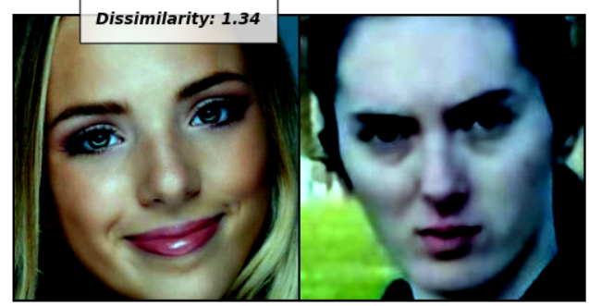

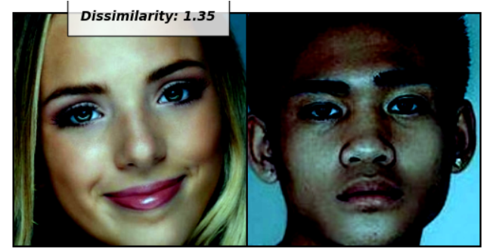

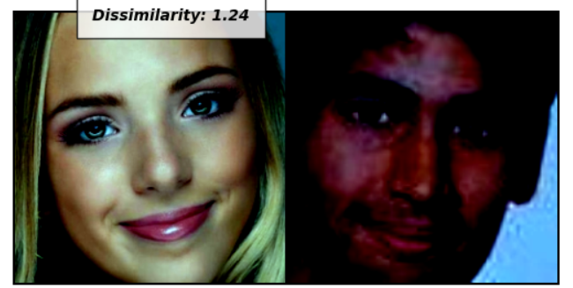

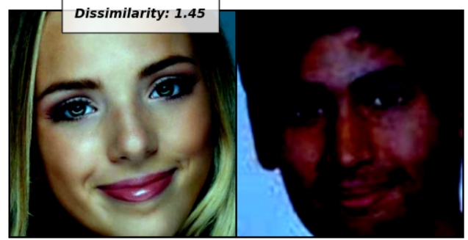

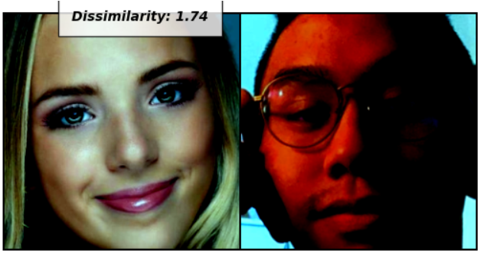

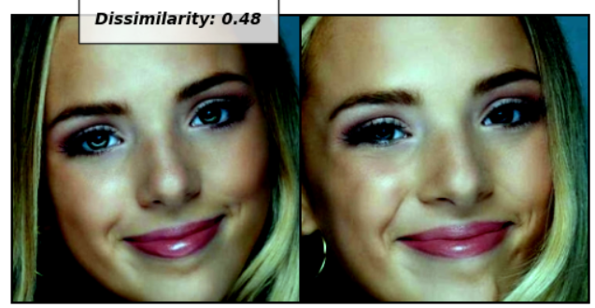

Now we upload and comparetwo images, where one is termed as the anchor image (x0) and the other is test image (x1), within the context of face detection and recognition using a Siamese network. Firstly, the function `upload_image()` enables the user to upload images. Then, the images are processed through a predefined transformation and are passed through the Siamese network. Subsequently, the Siamese network calculates the dissimilarity between the embeddings of the two images, representing the degree of dissimilarity or similarity between the faces depicted in the images. Finally, the concatenated images along with the dissimilarity score are displayed to the user. This process forms a crucial component of the face detection and recognition system, facilitating interactive evaluation and comparison of facial features, thereby contributing to the overall functionality and usability of the system.

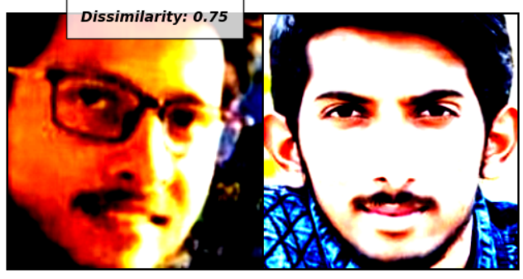

**IMPLEMENTATION WITH GRADIO:**

This defines a Siamese Network architecture for face detection and recognition. It comprises convolutional layers followed by fully connected layers for similarity comparison. The convolutional layers extract features from input images, while the fully connected layers perform similarity comparison between pairs of images. During the forward pass, input images are passed through the convolutional layers, followed by flattening and passing through fully connected layers. The output consists of two values representing the similarity between the input images. This Siamese Network architecture will be integrated with ResNet-50, ResNet-18, and VGG16 architectures to jointly learn discriminative face representations and facilitate accurate face detection and recognition.

**FACE RECOGNITION:**

**VGG-16 MODEL ARCHITECTURE:**

We are using VGG16 architecture for face recognition. It loads the pre-trained VGG16 model without its top or fully connected layers and freezes the last four layers to prevent them from being trained further. Then, a custom fully connected head is added to the base VGG16 model, consisting of global average pooling followed by multiple dense layers with ReLU activation and a softmax output layer with the number of classes set to 4. This fully connected head serves as the classification layer for recognizing faces into different categories. Finally, the base VGG16 model is combined with the custom fully connected head to create the complete recognition model. This process enables the utilization of VGG16 for face recognition tasks within the broader context of the project focused on face detection and recognition using Siamese networks with ResNet-50 and ResNet-18 architectures.

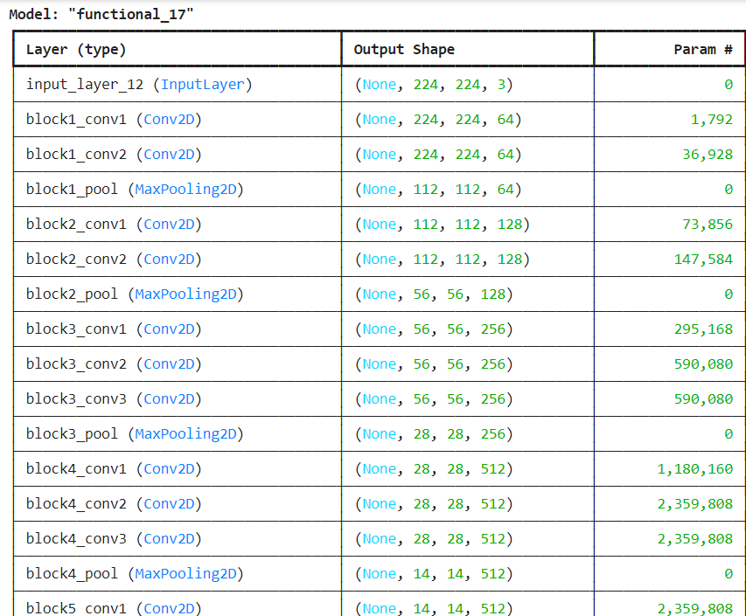

**IMAGE DATA PROCESSING:**

Here we setup an Image Data Generator for data augmentation, which will be used during training and validation of the face detection and recognition models. For the training dataset, various augmentation techniques such as rotation, shifting, and horizontal flipping are applied to increase the diversity of training samples and improve the model's generalization capability. The validation dataset is rescaled to ensure consistency in preprocessing across datasets. Both generators are configured to resize images to a specified target size, and the batch size is set to a typical value of 32. These data generators will be used to generate batches of augmented images for training and validation, facilitating the training process of the Siamese network with ResNet-50, ResNet-18, and VGG16 architectures for face detection and recognition.

Found 26 images belonging to 4 classes.

Found 25 images belonging to 4 classes.

**MODEL TRAINING:**

We here demonstrates the implementation of face recognition using a deep learning model in Keras, specifically employing a Siamese network with ResNet-50, ResNet-18, and VGG16 architectures.

The process involves:

1. Model Checkpoint and Early Stopping: Model Checkpoint is used to save the best model based on validation loss, while Early Stopping terminates training if validation loss does not improve for a specified number of epochs.
2. Optimizer Configuration: RMSprop optimizer with a learning rate of 0.001 is defined for compiling the model.
3. Model Compilation: The model is compiled with categorical cross-entropy loss and the defined optimizer, with accuracy as the metric.
4. Training: The model is trained using the fit method, specifying the training and validation generators, number of epochs, and batch size.
5. Model Saving: After training, the trained model is saved as "face_recognition.h5".

This process encapsulates the training and evaluation of the face recognition model, leveraging the Siamese network with ResNet-50, ResNet-18, and VGG16 architectures.

**PREDICTION AND VISUALIZATION:**

Here we utilized a pre-trained deep learning model for face recognition, specifically a classifier loaded from a Keras model file. It iterates through a set number of iterations, each time randomly selecting an image from a validation directory. The selected image is resized, preprocessed, and fed into the loaded classifier to make a prediction. The predicted class label is then displayed on the image, along with the original image, using OpenCV functions. This process simulates the face recognition task by predicting the identity of individuals in randomly selected images from the validation dataset. Overall, It demonstrates the utilization of a pre-trained model for face recognition and its application on real-world images for identification purposes. This functionality complements the broader objective of the project, which focuses on implementing face detection and recognition using Siamese networks with ResNet-50, ResNet-18, and VGG16 architectures to enhance accuracy and robustness in face-related tasks.

Class - keshav

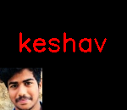

Class - keshav

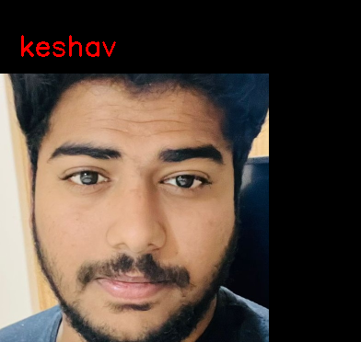

Class – Keshav



Class-sreeni

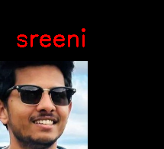

Class-komal

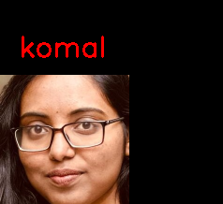

1. **CONCLUSION:**

In conclusion, the project successfully demonstrates the effectiveness of employing deep learning techniques for face detection and recognition tasks using a Siamese network with ResNet-50, ResNet-18, and VGG16 architectures. Through the implementation and training of the Siamese network on a diverse dataset capturing various facial characteristics, we have achieved robust face detection capabilities. By leveraging the distinctive features of ResNet-18 and ResNet-50 as base models for feature extraction within the Siamese network, accurate representations of facial features have been obtained, enabling the network to discern similarities and dissimilarities between faces accurately. Additionally, the incorporation of VGG16 architecture for face recognition further enhances the project's capabilities, as VGG16's powerful convolutional layers and fully connected head enable accurate classification of faces into different categories based on their features. The project's successful implementation underscores the potential of deep learning models in addressing complex tasks such as face detection and recognition, with the Siamese network and VGG16 architecture serving as effective tools for achieving high accuracy and robustness in real-world scenarios. Through this project, valuable insights have been gained into the application of deep learning techniques for facial analysis, paving the way for further advancements in the field of computer vision and biometric authentication systems.

1. **FUTURE WORK:**

Future work for the project "Face Detection and Recognition Using Siamese Network with ResNet-50, ResNet-18, and VGG16" encompasses several avenues for advancement. This includes the augmentation and diversification of training data to capture a broader spectrum of facial characteristics, alongside exploration into optimization techniques for refining model performance. Additionally, enhancing model architectures with advanced features like attention mechanisms could further improve accuracy and efficiency. Deployment into real-world applications demands rigorous testing for robustness, scalability, and privacy considerations, while continual learning strategies ensure adaptability to evolving facial patterns and environmental conditions. Integration with user-friendly interfaces and existing systems, coupled with ongoing research into privacy-preserving methods and security enhancements, will be crucial for practical implementation and widespread adoption of the system.

1. **REFERENCES:**

* https://www.researchgate.net/publication/372198002_Face_Detection_and_Recognition_using_Siamese_Neural_Network
* https://ieeexplore.ieee.org/abstract/document/8302003